

Everest - Apache Configuration

Disclaimer
Information in this document is subject to change without prior notice. Companies, names and data, if any are used in examples herein are fictitious and for illustration purposes only, unless otherwise stated. No part of this document may be reproduced or transmitted in any form or by any means, electronic or mechanical, for any purpose, without the express permission of EverestIMS Technologies.

EverestIMS Technologies may have patents or pending patent applications, trademarks, copyrights, or other intellectual property rights covering subject matter in this document. The furnishing of this document does not give external parties any license to these patents, trademarks, copyrights, or other intellectual property rights except as expressly provided in any written license agreement from EverestIMS Technologies.

EverestIMS Technologies and Everest are trademarks of EverestIMS Technologies Pvt. Ltd. All other brand and product names are trademarks or registered trademarks of their respective holders.

Microsoft is a registered trademark of Microsoft Corporation.

All other trademarks are the property of their respective owners.

Privacy Information

This document contains sensitive information. Access to this document or the content within should strictly be provided only to authorize users of EverestIMS Suite of solutions, on a need to know basis.

Any unauthorized use or sharing of information contained within this document will be considered as breach of respective confidentiality/copyright and shall be treated accordingly.

Company Information

URL: http://www.everestims.com/
Technical Inquiries: support.ims@everest-ims.com
Contact Information
# 45, BN Rao Plaza, 1st & 2nd Floor,
24th Main Road, JP Nagar 7th Phase,
Bangalore – 560 078.

Table of Contents
Disclaimer 2
Privacy Information 2
Company Information 2
1. Everest IMS Portal - Apache Configuration 4
1.1. Requisites of YUM Dependency 4
1.2. Ownership permission to the httpd folder 6
1.3. Disabling SELINUX permanently 7
1.4. Applying certificate in SSL 7
2. Everest IMS Admin - Apache Configuration 8

Everest IMS Portal - Apache Configuration

Requisites of YUM Dependency

Yum install httpd
Yum install httpd-devel
Yum install mod_wsgi
Yum install mod_ssl

- Copy portal.conf into etc/httpd/conf.d/

- Copy the below content into httpd.conf file. (at last line. /etc/httpd/conf/httpd.conf)
# in httpd conf - /etc/httpd/conf/httpd.conf
-----------------------------------------------------------
Header edit Set-Cookie ^(.*)$ $1;HttpOnly;Secure
ServerTokens ProductOnly
ServerSignature Off
Timeout 1000
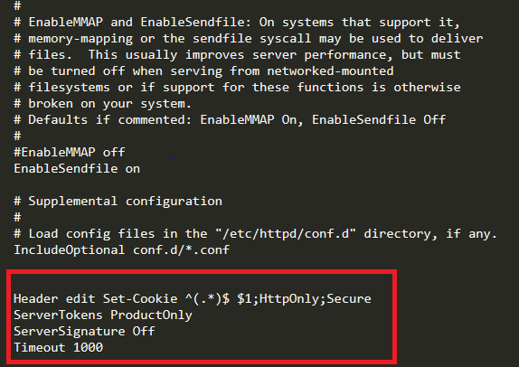

- Open ssl.conf from /etc/httpd/conf.d
Search for the line SSLProtocol all -SSLv2 -SSLv3

- Comment line: SSLProtocol all -SSLv2 -SSLv3

- Paste the below line

SSLProtocol -all +TLSv1.2

- Search for: SSLCipherSuite HIGH:3DES:!aNULL:!MD5:!SEED:!IDEA

- Comment line: #SSLCipherSuite HIGH:3DES:!aNULL:!MD5:!SEED:!IDEA

- Paste the below line
SSLCipherSuite HIGH:!kRSA:!kDHr:!kDHd:!kSRP:!aNULL:!3DES:!MD5

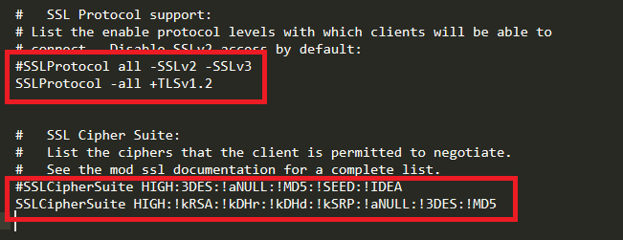

- Add the below lines in ssl.conf before the </Virtualhost> line

Alias /static /opt/portal/source/everest/media
<Directory /opt/portal/source/everest/>
<Files wsgi.py>
Order allow,deny
Allow from all
Require all granted
</Files>
</Directory>

Alias /bulkreport/ "/usr/share/httpd/bulkreport/"
<Directory "/usr/share/httpd/bulkreport/">
Order allow,deny
Allow from all
# New directive needed in Apache 2.4.3:
Require all granted
</Directory>

WSGIDaemonProcess EverestPortalssl python-path=/opt/portal/source:/opt/portalenv/lib/python2.7/site-packages
WSGIProcessGroup EverestPortalssl
WSGIScriptAlias / /opt/portal/source/everest/wsgi.py
WSGIPassAuthorization On

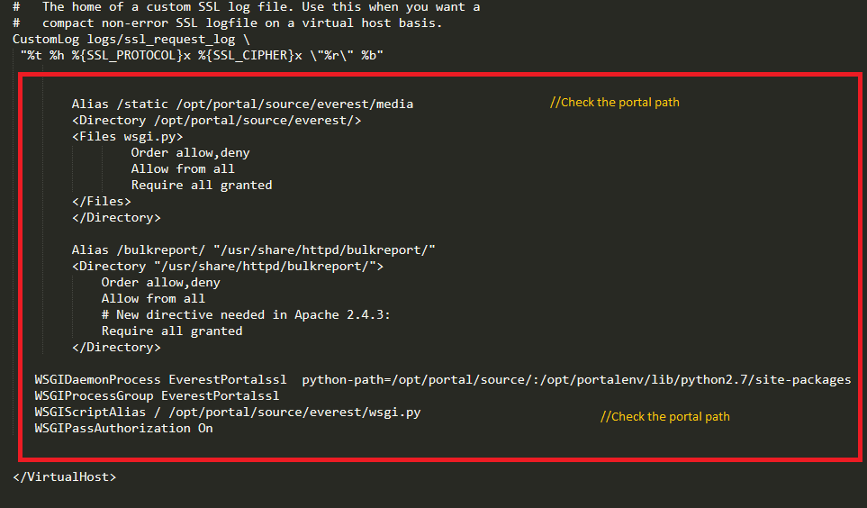

Note: Ensure that the path mentioned in portal.conf i.e. /etc/https/conf.d/ is correct.

Ownership permission to the httpd folder

- Go to the location cd /usr/share
chown -R apache httpd

Disabling SELINUX permanently

- Open the file vi /etc/selinux

- Chane SELINUX enabled to disabled
SELINUX=disabled
setenforce 0
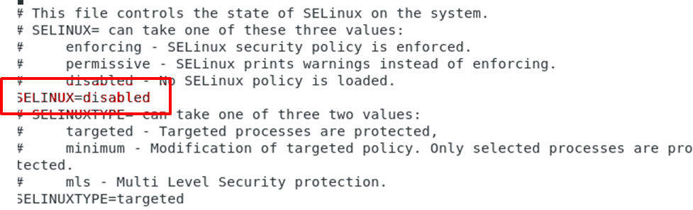
- Restart Apache service
Service httpd start
Service httpd status

Applying certificate in SSL

- Copy the certificate file in /etc/pki/tls/certs/

- Mention the path along with the file name in ssl.conf

- SSLCertificateFile /etc/pki/tls/certs/localhost.crt

- Copy the key file in /etc/pki/tls/private/

- Mention the path along with the file name in ssl.conf

- SSLCertificateKeyFile /etc/pki/tls/private/localhost.key

Everest IMS Admin - Apache Configuration

- # Copy the everest.conf file into /etc/httpd/conf.d/

- Change NMS admin IP and port in everest.conf file.

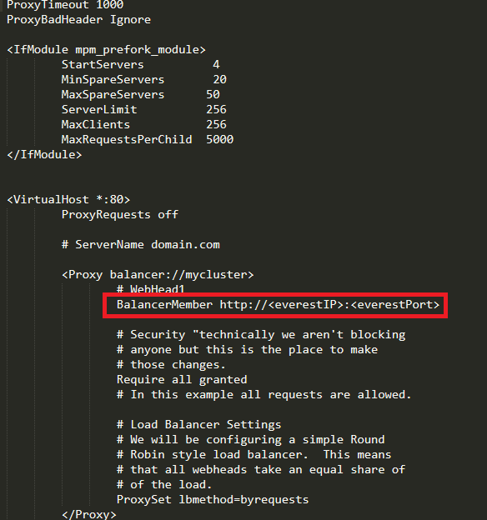
- Paste the bellow content in ssl.conf at the end
<VirtualHost _default_:9443>
ErrorLog logs/ssl_error_log
TransferLog logs/ssl_access_log
LogLevel warn
SSLEngine on
SSLProtocol -all +TLSv1.2
SSLCipherSuite HIGH:!kRSA:!kDHr:!kDHd:!kSRP:!aNULL:!3DES:!MD5
SSLCertificateFile /etc/pki/tls/certs/localhost.crt
SSLCertificateKeyFile /etc/pki/tls/private/localhost.key
<Files ~ "\.(cgi|shtml|phtml|php3?)$">
SSLOptions +StdEnvVars
</Files>
<Directory "/var/www/cgi-bin">
SSLOptions +StdEnvVars
</Directory>
BrowserMatch "MSIE [2-5]" \
nokeepalive ssl-unclean-shutdown \
downgrade-1.0 force-response-1.0
CustomLog logs/ssl_request_log \
"%t %h %{SSL_PROTOCOL}x %{SSL_CIPHER}x \"%r\" %b"
ProxyRequests off
# ServerName domain.com
<Proxy balancer://mycluster>
# WebHead1
BalancerMember http://<everestIP>:<everestPort>
# Security "technically we aren't blocking
# anyone but this is the place to make
# those changes.

Require all granted
# In this example all requests are allowed.
# Load Balancer Settings
# We will be configuring a simple Round
# Robin style load balancer. This means
# that all webheads take an equal share of
# of the load.
ProxySet lbmethod=byrequests
</Proxy>
# ProxyPass /eve_ims/ http://202.92.239.2:8000/
# ProxyPassReverse /eve_ims/ http://202.92.239.2:8000/
ProxyPass / balancer://mycluster/
RewriteEngine On
RewriteCond %{REQUEST_METHOD} ^(TRACE|TRACK)
RewriteRule .* - [F]
</VirtualHost>

- # Change the NMS IP and port

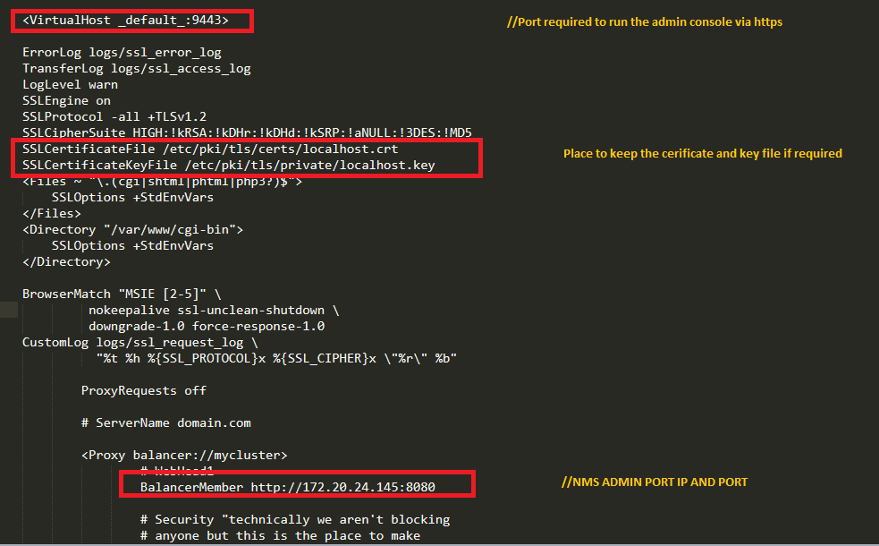

- # Add the virtualhost port in ssl file at beginning.

Listen 9443 https

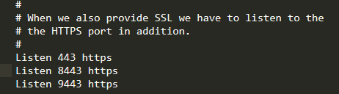

- # Restart httpd

Service httpd restart

Service httpd status

